**u|Lg ;f];fO6L klAns :s'n**

**/Tggu/–&, ;f}/fxf lrtjg**

**bf];|f] q}dfl;s** परीक्षा**—@)*@**

**sIff M–** o'= s]= hL= **समय - @ 3+=** **k"0f{fÍM– %)** **ljifoM–** g]kfnL

|  |
| --- |
| **gfd : ====================================================/f]n g+=============;]S;g M ================** |
| **_________________________ ______________________ s'n k|fKtf**Í **:**  **lg/LIfssf] ;xL k/LIfssf] ;xL** |

**k|Zg g+= ! rf/ cIf/n] ag]sf zAbx¿ n]Vg'xf];\ . -#_**

**k|Zg g+= @ bL3{ O{sf/ -L_ nfu]sf zAbx¿ n]Vg'xf];\ . -#_**

**k|Zg g+= # zAb agfpg'xf];\ . -%_**

**k|Zg g+= $ nofTds gePsf] zAbdf uf]nf] 3]/f nufpg'xf];\ . -%_**

**afn'jf xn'jf n;'g**

**d';f s'gf 6';f**

**;'v r'/f d'v**

**k'n ;'uf s'n**

**df;' k'/ ;'/**

**k|Zg g+= % j0f{ 5'6\ofP/ n]Vg'xf];\ . -%_**

**k|Zg g+= ^ qmd ldnfP/ n]Vg'xf];\ . -%_**

nfu'a Ö

ng;' Ö

nkm" Ö

d5f Ö

s8fk Ö

|  |  |  |  |  |  |
| --- | --- | --- | --- | --- | --- |
|  |  |  |  |  |  |
|  |  |  |  |  |  |

**k|Zg g+= & afx|v/L n]Vg'xf];\ . -^_**

**s**

**k|Zg g+= * P]sf/ nfu]sf zAbx?nfO{ uf]nf] 3]/f nufpg'xf];\ . -^_**

**;'uf hg} d';f**

**uLtf sL/f P]gf**

**w/} tf/f lkª**

**lsnf ;}lgs lstfa**

**cfdf lan k}tnf**

**d}bfg df5f ahf/**

**k|Zg g+= ( lrq x]/]/ gfd n]Vg'xf];\ . -^_**

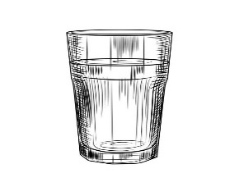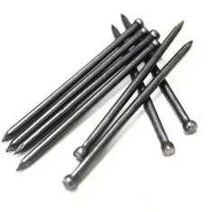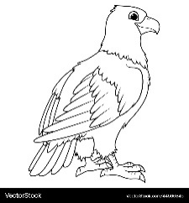

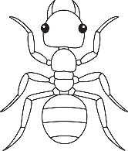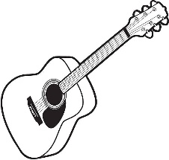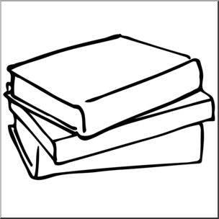

**k|Zg g+= !) zJbx? hf]8]/ jfSo agfpg'xf];\ . -^_**

df5f /fv .

hxfh ;dft .

hd/f r9 .

**;dfKt**